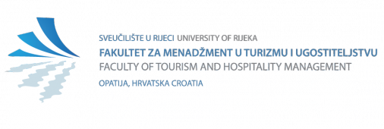

STATEMENT OF HOST INSTITUTION
Erasmus+ Programme
Academic year 20__/20__
Staff member data (please underline)
Name:
Surname:
Date of Birth:
Home Institution:
Erasmus ID code
(eg. B BRUXEL01):

The undersigned representative of the Host Institution hereby confirms that the above mentioned staff member has realized Erasmus+ mobility period at host Institution:
Confirmation of arrival and departure
Date of Arrival: | XX.XX.20XX
Date of Departure: | XX.XX.20XX
Type of Mobility: | 1) Teaching assignment (8 hours per week)  2) Staff training

Name, Surname, Position of the host HEI Representative  Kristina Črnjar, Ph.D., Assistant Professor, Vice Dean for International Affairs  Signature:  Date: | Stamp of Host Institution

Host Institution data
Host Institution:  Erasmus ID code  (eg. BE Bruxelles01): | Faculty of Tourism and Hospitality Management, University of Rijeka  HR RIJEKA01
Address, City, Country: | Primorska 42, p.p. 97, HR – 51410 Opatija
Host faculty, department, Unit | /
Contact person*  Name, Surname, Title, Position  E-mail address | Kristina Črnjar, Ph.D., Assistant Professor  Vice Dean for International Affairs  kcrnjar@fthm.hr
- Contact person may be professor, mentor, institutional, ECTS or Erasmus coordinator

