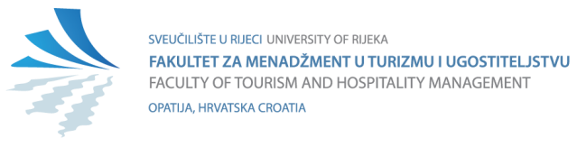

STUDENT – AUTHOR DECLARATION
ON THE PUBLICATION OF THE DEFENDED BACHELOR'S/MASTER'S/DOCTORAL THESIS

Click or tap here to enter text. | Click or tap here to enter text.,
(Student's full name) | (Student ID number JMBAG)

I hereby declare that I have completed this work independently, and that all parts of the work, findings, or ideas which are cited or based on other sources (including books, scientific or professional articles, internet pages, laws, and similar) are clearly indicated as such in the text and listed in the bibliography.

I hereby declare that, as the student – author of the Bachelor’s thesis, I grant the Faculty of Tourism and Hospitality Management of the University of Rijeka permission to permanently publish it and make it freely accessible to the public in full text within the online digital repository of the Faculty of Tourism and Hospitality Management, University of Rijeka.

In order to support open access to bachelor’s, master’s and doctoral theses that are permanently published in the publicly accessible digital repository of the Faculty of Tourism and Hospitality Management, University of Rijeka, by means of this declaration I grant a non-exclusive right of use, without substantive, temporal or territorial limitation, of my Bachelor’s thesis as an authored work under the terms of the Creative Commons licence CC BY Attribution, as described at http://creativecommons.org/licenses/.

Opatija, 26.11.2025

Student - Author:

(Signature)

