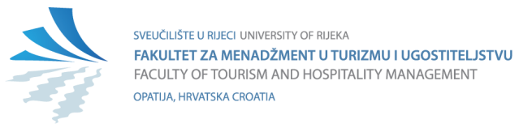

Request for Recognition and Assessment of Prior Learning

INFORMATION ABOUT STUDENT
NAME: | Click or tap here to enter text.
OIB: | Click or tap here to enter text.
Date of birth / City / Country of birth: | Click or tap here to enter text. | Click or tap here to enter text. |  | Click or tap here to enter text.
Student status: | Choose an item.
Higher education program: | Choose an item.
Student ID /JMBAG: | Click or tap here to enter text. |  | Click or tap here to enter text.
E-mail / Phone number: | Click or tap here to enter text. |  | Click or tap here to enter text.

R.br. | The request for recognition and evaluation of prior learning is based on:
 | Certification of completion of a programme or part of a programme | Institution Name: | Click or tap here to enter text.
 |  | Study Period: | Click or tap here to enter text.
 |  | Program Name: | Click or tap here to enter text.
 |  | Level of the previous study program: | Choose an item.
 |  | I suggest recognition of the following courses: | Click or tap here to enter text.
 | Non-formal, uncertified education and informal learning | Specify: | Click or tap here to enter text.
 | Other: | Specify: | Click or tap here to enter text.

Justification (if necessary):
Click or tap here to enter text.

Student's Signature: Only if the application is submitted in person to the Student Office
Date: | Click or tap to enter a date.

*************************************************************************************
Attachments in digital versions (scanned in PDF or JPG format):

- For the recognition of formal and non-formal certified education:
- Certified transcript of grades or a certified copy of the supplementary document.
- Certified detailed description of subjects or programmes (including content, number of teaching hours, description of acquired competencies, method of assessing learning outcomes, list of literature, number of ECTS points achieved, etc.) for which recognition is sought.
- Certificate of completion of the programme or part of the programme.

- For the recognition and evaluation of prior non-formal uncertified education or informal learning, the student or applicant may provide any evidence they believe demonstrates the acquired learning outcomes and competencies for which recognition and evaluation are sought (e.g. certificates, authored works, information on previous education or work experience, etc.)*

- Other
NOTE:
- An applicant seeking recognition of outcomes achieved in any studies at the Faculty of Tourism and Hospitality Management is required to submit only the completed and signed application, with no additional documentation needed.
- Applications with the corresponding documentation should be submitted to the email address priznavanje@fthm.hr or in person at the Student Office on the ground floor of the Faculty building.
- Incomplete applications will not be considered.

*For students seeking recognition and evaluation of prior non-formal, uncertified education or informal learning, an assessment of learning outcomes will be conducted in accordance with the general regulations of the University of Rijeka and the Faculty.

