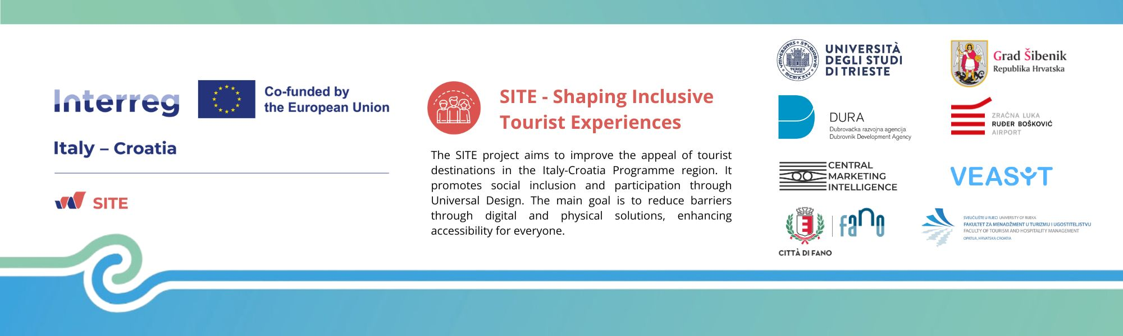

Scientific conference SITECON 2026:
Shaping Inclusive Tourist Destinations & Societies
27th May 2026, Opatija, Croatia
University of Rijeka, Faculty of Tourism and
Hospitality Management

ABSTRACT SUBMISSION FORM

TITLE OF THE PAPER

EXTENDED ABSTRACT (400 - 800 words) has to be structured into 4 sub-headings (PURPOSE, METHODOLOGY, FINDINGS, CONTRIBUTION)
Purpose -

Methodology -

Findings -

Contribution -

Key words (4 -6)
References (optional)
All citations and references must follow APA (American Psychological Association) style (https://apastyle.apa.org/style-grammar-guidelines/references/examples).

AUTHOR 1 PERSONAL DETAILS - Corresponding author
TITLE
FIRST NAME (s)
SURNAME
POSITION
INSTITUTION
ADDRESS
COUNTRY
PHONE NUMBER
E-MAIL

AUTHOR 2 PERSONAL DETAILS
TITLE
FIRST NAME (s)
SURNAME
POSITION
INSTITUTION
ADDRESS
COUNTRY
PHONE NUMBER
E-MAIL

AUTHOR 3 PERSONAL DETAILS
TITLE
FIRST NAME (s)
SURNAME
POSITION
INSTITUTION
ADDRESS
COUNTRY
PHONE NUMBER
E-MAIL
…
(Please, add more tables for additional authors if necessary)

